1.
Multi-Step Object Re-Identification on Edge
Devices: A Pipeline for Vehicle Re-Identification
Tomass Zutis, Anzelika Bureka, Janis Judvaitis, Peteris Račinskis, Janis Arents, Modris Greitans
Institute of Electronics and Computer science, Latvia
Abstract

A method that leverages a multi-step process focused on extracting and using object features for object re-identification is described. The proposed pipeline includes steps such as: detecting an object, converting its features into a vector embedding, storing this embedding in a vector database, and then querying the database to find the same or similar objects based on their feature embeddings. This approach allows for the identification of the same object across different images or cameras, even in varying locations, such as in Vehicle Re-Identification scenarios. For situations where re-identification needs to happen in outdoor environments or on-the-go, implementing this process on edge devices becomes crucial. Therefore, multiple ways to tailor the pipeline and its outputs for edge devices are outlined and investigated. The presentation provides a detailed explanation of the pipeline’s structure and how it functions on edge devices, along with the experimental setup demonstrating its application, particularly in vehicle re-identification.
Keywords Re-Identification, Feature extractions, Vector embeddings, Neural networks, Edge devices, Vector databases, Traffic monitoring.
List of Notations and Abbreviations

Introduction

Monitoring and recognizing objects in photos and videos has long been a field of interest. It has become a well researched topic ever since computer vision has accelerated it’s possibilities, in the last decade especially [1]. With computer vision came image classification, which helped us classify images based on the object depicted. That gave us the answer to the question: ”What is the object in the image?” [2]. Later came great progress in object detection. That could answer the questions of: ”Where are the objects in the image?” and ”What are the objects in the image”. This was advanced by the Convolutional Neural Network (CNN) and its variants [3]. In this article, however, the authors are looking for a solution that could see objects of a single class and distinguish between them, using the specific features that exist only for a single individual in a class. This problem is called object Re-Identification - widely regarded as a sub-problem of image retrieval [4]. In imagery from at least two different cameras (scenes), object re-identification aims to correctly label the same individual after imaging conditions (like scene, lighting conditions, object pose and others) have changed. These could be images of vehicles, people or even animals or simple in-animate objects that have great intra-class variations (See fig. 1.1). We are also in a unique position where there is still a lot of research to be done on re-identification itself, however, at the same time we are faced with the need to tailor these solutions for edge computing to preserve relevance in global technology and research trends. This is because some of the most common applications of re-identification are in traffic and security that use network cameras and cloud computing [5] [6]. Cities are looking for edge-computing devices using computer vision and deep neural networks to track real-time events in the public space. With the development of the Internet of Everything (IoE), the number of smart devices connected to the internet, the volume of available video footage, and the influx of sensory data have made the large-scale accumulation of big data inevitable [7]. This is why fully automated systems are needed to process data and re-identify patterns and objects in the smart cities environment, for no human or group of humans can be employed to process all this data manually and more crucially - in real time.
In the scenario of traffic monitoring, there is the need to re-identify vehicles on the go to: first, be able to track them in a road network and, second, model future traffic based on the existing patterns [5]. Edge computing proposes a hardware and software solution that would do this in real time – live video feed would be received from a network camera and the video analytics (i.e. detection and re-identification algorithms) are run directly on the edge device and only the results of the processing are transmitted.

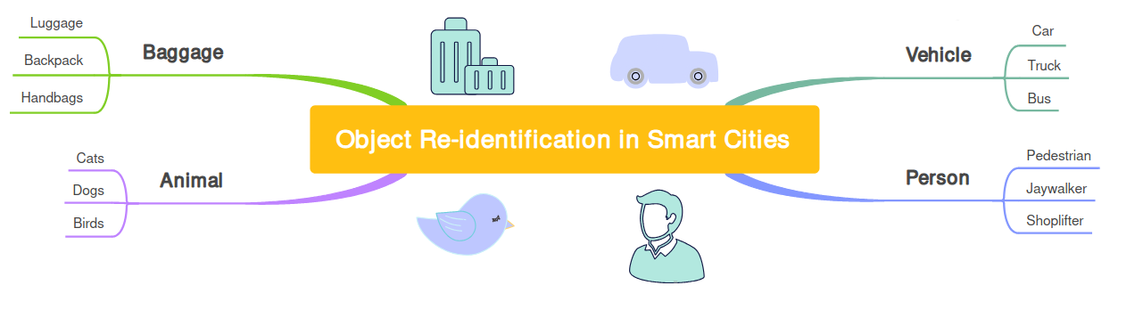Figure 1.1 There are multiple uses for object re-identification in the smart cities context. Some of them are people, vehicles, animals and even luggage in transit hubs.

The natural solution to the object re-identification problem in these circumstances is a pipeline consisting of algorithms designed to cover all the necessary steps for re-identification to work. We argue that constructing a pipeline that receives live video feed, processes the frames to extract objects from each frame, saves these objects into memory and recognizes the same objects in a different scene’s live video feed is possible and we aim to describe it in detail.

Related work and state of the art
Object re-identification to this day is heavily reliant on extracting robust feature representations for the objects we are trying to save. Differences in lighting, angle, occlusions, multiple models of the same object (vehicle) are an obstacle in getting reliable predictions [8]. However, there is more to a working re-identification pipeline than just looking for the best way to produce vector embeddings. We have looked at the state of the art for multiple components of this problem, such ass: Object detection, Object re-identification and feature extractions, Person re-Identification, Vehicle re-identification, Available datasets, Synthetic datasets and Edge implementation.

Object detection
Convolutional neural networks (CNNs) have been incredibly incremental in computer vision tasks, including object detection. YOLO - the "You Only Look Once" model is one of the best performing and regularly maintained choices. The latest YOLO v8 version (in the authors opinion v8 is the latest model with widespread and public support) has shown significant improvements in accuracy and speed [9], which is crucial for real-time applications like ours. YOLO v8 leverages the experience from the previous YOLO versions, having around 10% better mean average precision in object detection than the previously popular v5 (when comparing medium model size).

Object feature extraction
Feature extraction is used to extract the most distinct features from an image, which is used to describe it. We try to save these features in a low dimensional vector space [10]. Before image feature extraction, multiple pre-processing stages are usually employed like normalization, thresholding, binarization, resizing and others. We can expect a model to extract: colour, texture, shape, motion and localization features. However, when dealing with one class objects with small intra-class variations specific types of features can be learned by the model like face features in the case of facial recognition.
As of 2024 CNNs have become predominant choices in object features extraction thanks to their strong representation power and the ability to learn deep invariant embeddings [11].

Vehicle re-identification
It is the case that in re-identification, there seems to be a better tailored model for each benchmark out there. For example, in the realm of Vehicle Re-ID benchmarks MBR4B-LAI model by Almeida et al. [12] tops the VeRi-776 benchmark, "A strong baseline" model by Huynh et al. [13] tops the CityFlow benchmark and the vehiclenet model by Zheng et al. [14] is best at the VeRi benchmark. However, we have chosen to pay particular interest to the paper by Zheng et al. because of the baseline model that is applicable to all types of object re-identification and feature extraction. In [15] Zheng et al. first introduces us to their baseline model and its architecture and demonstrates its capabilities specifically in pedestrian re-identification. In further papers, however, Zheng et al. demonstrate tailoring of this baseline to vehicle re-identification [14], [16] and person re-identification [11]. We underline this baseline models usefulness by the versatility of its use in publications, its open code base and customizability and its entry into most benchmarks. Even though it tops only one of them, it always keeps close to the top in terms of the Rank1 precision, according to the benchmark results on Papers with Code [17]. The model is implemented in Pytorch and is based on ResNet50 pre-trained on ImageNet, although this backbone is customizable.
We will further refer to this model of interest as "baseline model by Zheng et al.”

Person re-identification
The goal of Person re-identification is to match a person's visual identity across many different cameras or scenes. The SOTA in person re-identification can also be judged by the benchmark leaderboards available on Papers with code [18]. Some of the most important datasets-turned-benchmarks are: the Market-1501, where the current best Rank-1 accuracy is [19]; the DukeMTMC-reID where the current best Rank-1 accuracy is [20]; and the CUHK03 where the current best Rank-1 accuracy is [19]. A modified version of the baseline model by Zheng et. al. has made an entry in the CUHK03 leaderboard 6th place in Rank-1 accuracy with 89.63% and 3rd place in Rank-5 accuracy with 99.01%.

Available datasets
One of the amplest vehicle detection datasets - UA-DETRAC comes from Wen et al. [21]. The UA-DETRAC benchmark dataset consists of 100 challenging video sequences captured from real-world traffic scenes. It can be used for object detection model training or fine-tuning.
Some of the vehicle or person Re-ID datasets are already previously mentioned in the context of their usage in benchmarks. The VehicleID (PKU VehicleID) dataset has been introduced by Liu et al. in [22]. It includes 26'267 unique vehicles with 221'763 images in total. Each image is attached with an ID label corresponding to the vehicle identity. It is the dataset with one of the biggest unique ID collections and features pictures with different resolutions and quality of visibility as well as vehicles in motion state. Vehicles are mostly seen, however, from the front and the back only. The VeRi-776 introduced by Xinchen Liu et al. in [23] contains 49'357 images of 776 unique vehicles from 20 different cameras. Each image is attached with vehicle ID, bounding box, type, color, brand. The dataset makes up for its smaller set of unique id's compared to the VehicleID with better quality pictures, better visibility and vehicles from all angles not just back and front. The CityFlow dataset introduced by T Tang et al. in [24] is part of the AI City challenge and is a traffic camera dataset consisting of more than 3 hours of synchronized HD videos from 40 cameras. The dataset contains 229'680 images and around 700 unique vehicles. The 2020 AI City challenge [25] includes this dataset as videos, but also as cropped vehicle images for ReID model training. The quality of images is high and vehicles can be seen from many angles. The difference between this and the previous two widely used datasets is the types of vehicles seen, namely, US American versus Chinese, which creates a great parameter shift (See fig. 2.1).

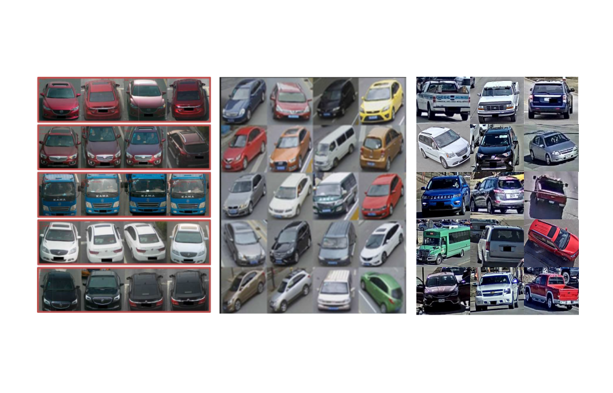 Figure 2.1 The difference between the distribution of vehicles shows us the parameter shift between the (from the left) VehicleID [22], VeRi-776 [23] and CityFlow datasets.

Synthetic datasets
When creating synthetic standalone datasets, there are risks learning features that do not generalize to real life images, however, when creating additions to already existing datasets, there is high risk of creating an appendix that has a great parameter shift from the rest of the dataset, thus causing problems with convergence.
The VehicleX synthetic dataset is created with these problems in mind. It contains generated images with domain adaptation from VehicleID, VeRi-776 and CityFlow datasets [26]. Each of these adapted versions can be paired with the original dataset to enhance learning results.

Edge implementation
If we want to meet the requirements of a real-time system, we need to implement a network that follows the edge-computing paradigm. The edge-computing paradigm means that the video analytics run directly on the device and only the processed results and analytics are transmitted [5]. Barthélemy et al. have developed a pilot project in Liverpool, Australia, where they use mobility trackers using live CCTV feeds, with twenty sensors deployed over the city with the objective of citywide traffic monitoring in real-time. The devices had the ability to transmit the outputs either over Ethernet or LoRaWAN networks and had two main components: 1.) an NVIDIA Jetson TX2 high performance and power efficient embedded computing device with special units for accelerating neural network computations used for image processing and running Ubuntu 16.04 LTS and 2.) a Pycom LoPy 4 module handling the LoRaWAN communications.

Proposed methodology
In this chapter we describe the proposed sequence of processes that would enable object re-identification: Object detection, feature extraction and saving and querying for an object in a vector database. We will touch on how these components fit together and how each part could be improved to better serve the common outcome. We will also introduce the application of this methodology in a smart city environment - the Vehicle ReID pipeline.

Object detection

When we have objects of interest included in images, but these images are not cropped to the dimensions of the object, we need to find the objects in the image and decide on the extent of their size. This is done with an object detection algorithm.
In theory, one could train or fine-tune their own object detection model to tailor for a specific object class. However, latest off the shelf detection models can detect vehicles or people, for example, with very high precision. As mentioned in the 2.1 section YOLO v8 model is regarded as very accurate and suitable for real-time applications.
We will be using the YOLO v8 model to detect the objects of a specific class, determine their bounding boxes and saving cropped out images of these object bounds.

Feature extraction

Once we have cropped images of the objects, we need to extract their features and turn them into vector embeddings. This can be done with a re-identification model, that has learned to extract the features of specific objects and save them in an embedding. For this we will use the baseline model by Zheng et al. As described in section 2.3, this baseline can be trained to fit vehicle, person or any other object re-identification. The model is implemented in Pytorch and can be readily customized. We will also use the surrounding project code for this model available on [27]. The author has provisioned tools to train, finetune, test and visualize the results of the inference process. The model code is available and can be modified in any stage.

Saving feature extractions

Once we have managed to extract features from such rich data like images, we need to find a way to store and compare the extractions in a computationally inexpensive way.
These features have been turned into n-dimensional vectors that consist of natural, real or complex numbers, where one number represents a feature or a part of a feature. We should be able to compare these vectors for their similarity, to be able to retrieve the most similar object to the one being queried for. We can do this by using the Cosine similarity function. Cosine similarity is widely used and requires an input of at least two unit-length normalized vector inputs to output a vector distance [28].
Efficient management of vector data would require a Vector database system, so vectors could be stored and queried as efficiently as possible [29]. This vector database will have to contain vector similarity search complemented by metadata filters. For a very simple interpretation of our task the database entries would simply be in the form of Key:Value = ObjectId:ObjectFeaturesVector while more fields for entries should be easy to add.

The Vehicle ReID pipeline

Having outlined the general components of object re-identification—such as object detection, feature extraction, and storing embeddings—this subsection will introduce the methodology that is specific to a vehicle re-identification pipeline that is currently under development.
We propose a pipeline that would take in video frames from a network camera x, detect the vehicles in the frames, crop images of the vehicles and save them, turn these cropped images into feature embeddings and then save them in a vector database. The same process would be repeated for a different camera y ... z, so that vehicles could be re-identified from camera x to y ... z or vice versa (see fig. 3.1).

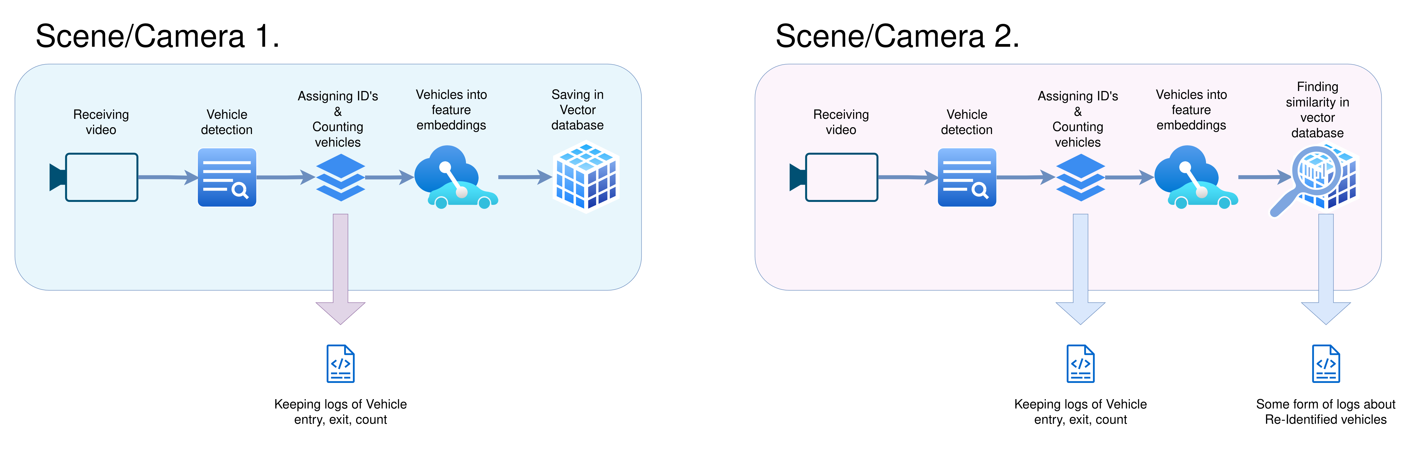Figure 3.1 The proposed structure of the re-identification pipeline.

To make sure we are developing a functional pipeline and can monitor the performance of each step we need to split the process into two parts, at least during the development stage:
- Vehicle counting and tracking
The purpose of this process will be to count, track and save information about the vehicles that have passed through the view of a single camera. It should receive the videos from a network camera, detect the vehicles, start tracking them and establish the sectors where we count incoming and outgoing cars (for example entries and exits in an intersection). The count, entry and exit times of cars should be continuously logged.

- Vehicle Re-Identification
Once we have vehicles detected and tracked, we need to decide on an approach about where and how often images of vehicles should be cropped out of the frame. Then we need to save these images, create feature extractions and save them in a vector database.

We will also need to make sure that the methods that make up the pipeline are well tailored for our purpose. We introduce the following points of action:

Establishing sensible counting and tracking solutions

We need to develop a solution that counts and tracks vehicles reliably, so that we know that the ReID process after that can run smoothly. We also need to keep a reliable log for supplementing the accuracy of ReID and analysis of the traffic flow.

Finding the best approach to save images of vehicles

It might be important to figure out where and how often should vehicles be cropped out of the frame. A specific position in the camera-view might be more advantageous to save the vehicle and could produce a better feature vector. Complimentary to that, saving the vehicle in multiple positions in the same view might make it more recognizable in a different camera.

Training the ReID model on different datasets

We need to make sure, that we have tried all the most widely used and publicized datasets (mentioned in 2.5), to see which fits best for our pipeline.

Going over model hyper-parameters
We need to go over many hyper-parameters during model training. It is valuable to make sure that the default training parameters listed for the baseline model by Zheng et al. also fits best for our use case.

Experimenting with changing the baseline model architecture

It can be valuable to see if changes in the architecture or prediction head of the baseline model by Zheng et al. could improve accuracy.

Testing the proposed methodology
Since the pipeline is in development, we will first need to conduct a series of tests for individual components and use cases, before we can bring the whole pipeline together for testing.
- Testing on a dataset
We need to test the model itself on a dataset to see the accuracy with which the model makes predictions in a very controlled environment such as cropped pictures of vehicles. However, this does not mean that the model must be tested exclusively on test data of the same dataset, we could also test the model on vehicle images from the network cameras we plan to be using it on.
- Testing on video tracks
To test all the components of the re-identification process part of the pipeline we might choose a pre-recorded scene of traffic that has ground truth available. We could skip the object detection and tracking part, hence the ground truth would let the pipeline know where the cars in the frame are and what is their pre-assigned ID. In this case only the bounding box cropping, feature extraction, saving and querying the database could be tested.

Before testing the re-identification functionality, it is important to test the vehicle counting step to make sure the process is accurate. This, however, falls slightly outside of the scope of the paper, so we have purposefully chosen to leave these sections out.

At the end of successful testing of all steps of the pipeline, one should create a video test scenario that starts with object detection and does not count on the ground truth bounding box and pre-assigned vehicle id data, encompassing both: 1.) vehicle counting and tracking and 2.) vehicle re-identification functionalities.

Edge device considerations

While the pipeline has been tested on a desktop computer with an 8GB GPU, this setup provides a rough estimate of the computational load and performance we might expect on edge devices like the NVIDIA Jetson series [30]. Current work suggests that despite differences in power consumption and architecture, the constraints with desktop testing can offer insights for edge deployment that we wish to implement in the future.

Experimental settings

While the general steps remain consistent with the proposed methodology, the experimental settings section will detail the practical set-up of mentioned concepts, fitted specifically to the use-cases of vehicle ReID in a smart city setting. We will describe the settings for the Vehicle counting and tracking part of the pipeline, Vehicle Re-Identification part of the pipeline, the available datasets used for training, synthetic data used to augment the datasets, going over hyper-parameters, experiments with changing the model architecture, creating tests and hardware used.

Vehicle counting and tracking
In this sub-section we will elaborate on the implementation of the counting and tracking part of the pipeline

Receiving video from a Network camera
To simulate a traffic scenario for tracking and ReID applications, we will use 3 AXIS P1427-LE Network cameras [31] that record footage from the same service road and a parking lot.
We are receiving the video in 1280x960 resolution with ~ 2 fps over RTSP, however, HTTP works as well. A 25-30% compression rate is employed as well for better data transmission.
The view from the cameras (See fig. 4.1) can be summarized in the following way:

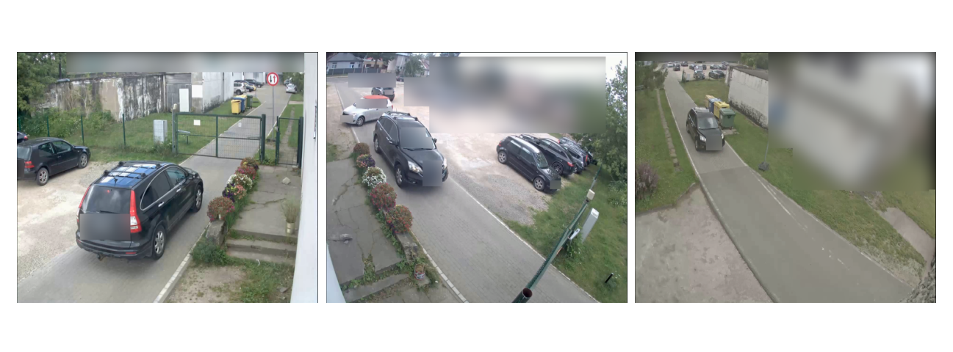
Figure 4.1 The same car visible in cameras (from the left) 1., 2. and 3., respectively.

- Camera 1.
This camera sees cars entering and exiting the inner service road from the parking lot from outside of the territory. Gates are also visible. It is located about 3 to 4 meters above ground and generally allows us to see both the front/back of the car and the sides of the car. For non-cargo vehicles, the roof is also visible.
- Camera 2.
This camera is located above the gates and can see into the parking lot. We can see the opposite side of the car as opposed to camera 1. It is also located about 3 to 4 meters above ground, however, cars are seen more from the front and the back, but skewed sides and roof are visible.
- Camera 3.
This camera is located deeper into the territory and generally sees the whole service road with the parking lot in a far distance. The camera is much higher than 1. and 2. and is about 6 to 8 meters above ground. We can see the front/back and roof of the car well, however, the sides are not visible in such quality because of the altitude and angle of the camera.

Object detection and tracking
After receiving the video frames from the network camera, we need to use the YOLO v8 model to detect the vehicles and get their bounding boxes. Further we will use the ByteTrack tracking package [32] to assign id’s to the vehicles and track them through the following frames until they leave the view of the camera.

Object counting and cropping
With ByteTrack, we now know when the vehicles have left or entered specific parts of the scene. We can use this to count the cars, by using the built in functions of Byte track, for example, drawLine - counting when a car drives past a drawn line (See Fig. 4.1).

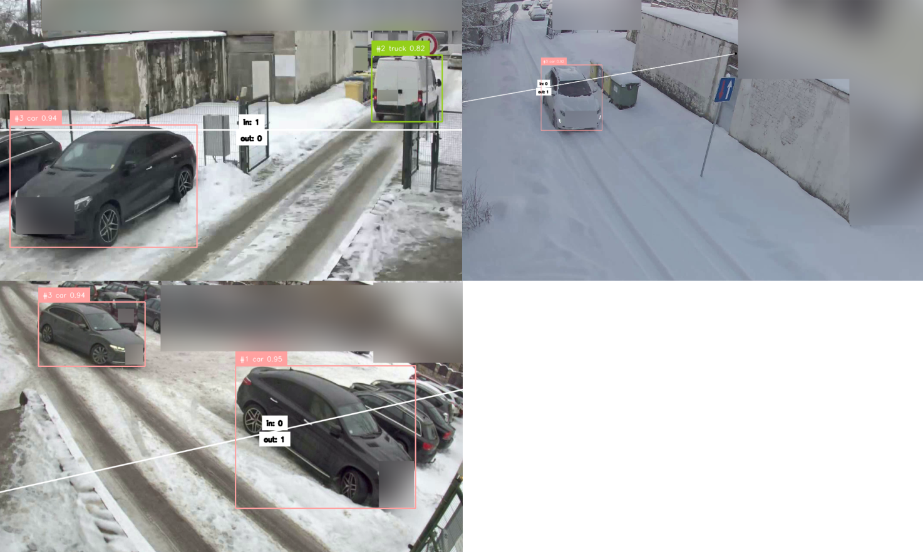
Figure 4.1 The implementation of the counting lines and ByteTrack in cameras (from the left) 1.,2. and 3.

In our case, however, modifications to the package had to be made, because the built-in function counted a car once it had fully been seen before the drawn line and subsequently completely after the line. In our cameras, however, the field of view is slightly limited when vehicles approach close to the gate, so we had to include the following provisions:
- A vehicle is counted also if they were first detected when already on the counting line (connection or resolution problems)
- A vehicle is counted also when it is no longer detected, but didn’t cross the line fully (most of the vehicle's area crossed the line before disappearing – can happen, when vehicle is large and is close to the camera)
- A vehicle was neither fully detected before or after the line, but switched location while existing on the line, by having most of its area shift from one side to the other (can happen if there are disruptions in the video).

These can also be important positions for cropping of the vehicles out of the frame. We could crop a few images of the vehicle even before it has been counted and in case it doesn't cross the line – we discard the images we would have otherwise saved.

Modes of testing
As previously mentioned in section 3.5 - the vehicle counting step itself falls shortly out of the scope of the paper. In general, however, testing the counting accuracy could be done by recording videos from our network cameras or using publicly available video tracks of vehicles. When recording test footage from our own network cameras, most of the testing had to be done manually i.e. by visually inspecting the footage, as there is no ground truth available.

Vehicle re-identification
In this sub-section we will elaborate on the experimental settings that enable re-identification in the pipeline. As mentioned in section 2.3 we have chosen the baseline model by Zheng et al. as our re-identification model and will further work to integrate this model into our pipeline.

Testing and data annotation
First and foremost, we should establish tests and create test data, that will let us evaluate the experiments. We will use a combination of both publicly available datasets and recorded test data from our network cameras:
- Benchmark datasets. By using benchmark datasets, such as Veri-776, we can access reliable test data, standardize our test metrics and evaluate the re-identification model itself.
- CityFlow test track video. By accessing the videos included in the CityFlow test tracks, we can test the whole re-identification part of the pipeline and simulate a real-world scenario where we are re-identifying vehicles in an intersection. We will be using the scenario Nr. 1 in this dataset, to re-identify vehicles from camera 1. to camera 4. [24]. There are around 2000 frames in each video and 91 unique vehicles seen. Both cameras point to the same intersection but from vastly different locations.
- Custom test data. We have recorded footage from 3 of our cameras. All of them cover overlapping sections of a service road inside a closed territory. The vehicles have been cropped from these videos and saved into 3 folders, each for its own camera. This dataset contains 70-100 images from each camera, with ~ 25 unique vehicle identities. We will use this data to, first and foremost, test the generalisation of our trained models to the actual data that we will use this pipeline on.

Training model on different public datasets
After the model has been selected, we need to choose a publicly available dataset to train our model on. We will train our model separately on the VehicleID, VeRi-776 and CityFlow datasets and based on the results, decide which one fits best for the test data we have gathered from our network cameras. It is worth training a model on a combined Veri-776 and VehicleID dataset, because of their similarity and check whether it provides a better result.
We will also combine the best performing standalone dataset with the Vehicle X synthetic data. The Vehicle X data, has three versions – each tailored to one of these datasets. We will add the tailored synthetic data to the train portion of the base dataset.

Improving our baseline model
Two different approaches will be made to improve the performance of the baseline model.
First, we will change the prediction head of the model during inference. The prediction head that the baseline model uses by default has three layers:
- Linear (in_features=2048, out_features=512)
- Batch Normalization 1d
- Dropout (with probability 0.5)
However, while it is beneficial to use batch normalization and dropout during training, they could theoretically decrease the vectors efficacy in describing features during inference. Especially, hence dropout removes half of the logits in the vector.

Secondly, when reviewing the model's hyperparameters during training, it's observed that the author focused primarily on parameters such as:

- Backbone,
- Learning rate,
- Warm epochs,
- Batch size, and
- Erasing probability,
but didn’t mention testing or highlighting the impact of other crucial parameters, like:
- Colour jitter,
- Size of the final linear layer (i.e., length of output),
- Cosine learning rate or
- Stride
to name a few. These parameters, though less emphasized in the published work and associated GitHub repository, could in theory influence the model’s performance and warrants experimentation.

Saving the feature extractions
To store and query feature embeddings, we have chosen LanceDB – an opensource database for vector search, built for efficiency in handling large-scale vector data, low-latency queries, and seamless integration with Python [33]. Its flexibility in saving and querying data—such as the incremental updating of embeddings—makes it ideal for our re-identification pipeline.
Additionally, we have come up with four methods (See table 4.1) for deciding when and where images of vehicles should be cropped from the frame when dealing with video scenarios and how they should be saved into the database:
- Basic Frame-by-Frame Saving: In this method, every frame in which the vehicle is detected is saved as a new vector under the same vehicle ID in the database. This creates multiple feature embeddings for the same vehicle.
- Vector Summing: Instead of storing every feature vector separately, we maintain a single vector per vehicle. Each frame's embedding is summed with the existing vector, and the result is divided by the total number of updates, averaging the embeddings over time. This process keeps track of how many times the vector has been updated by adding an additional field in the database.
- Zone-Based Saving: The frame is divided into zones using a grid, and a vehicle's feature embedding is saved once per zone it passes through (See figure 4.2). Typically, this results in 4-6 saved vectors per vehicle, depending on its trajectory as opposed to many more vectors when saving in every frame. Each instance of feature extraction is stored as a separate vector under the same vehicle ID.
- Zone-Based with Vector Summing: Similar to the zone method, but here, we apply vector summing. The vehicle’s vector is summed for every frame in which a vehicle has changed zones.
Table 4.1 Vehicle Cropping and Saving Strategies
Method | Number of saved vectors | Saving strategy | Embedding management
Basic frame-by-frame saving | Multiple (all frames) | Per Frame | New vector for each detection
Vector Summing | 1 | Per Vehicle | Sum and average of all vectors
Zone-Based Saving | 4-6 (based on zones) | Per Zone | New vector for each detection in new zone
Zone-Based with Vector Summing | 1 | Per Vehicle | Sum and average for each detection in new zone

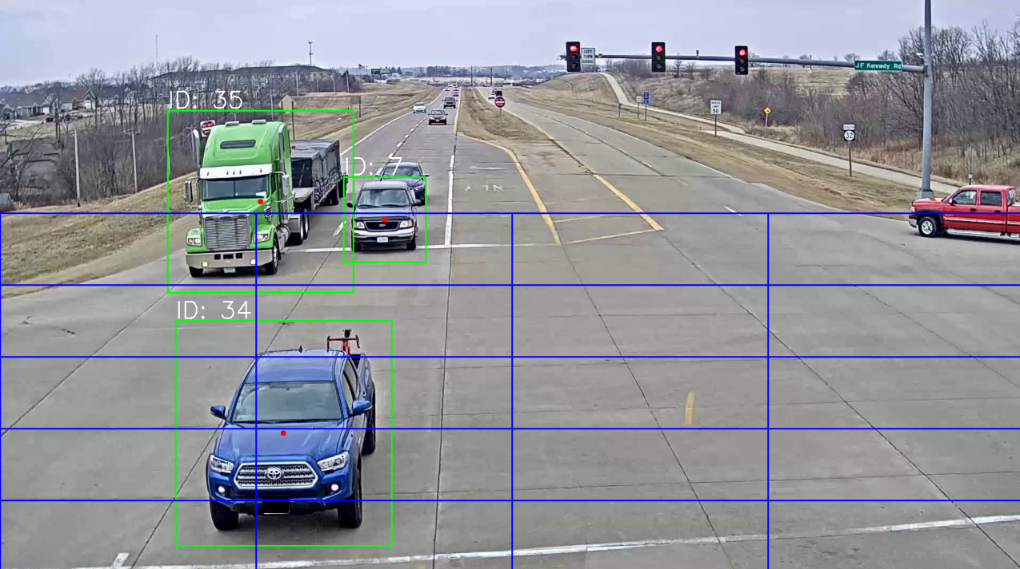Figure 4.2 The implementation of the saving zones that let the pipeline capture vehicles in multiple positions as seen on the CityFlow test track video.

Results
In this section we will go over the results of the experiments and approaches we have described earlier in the paper, such as: Finding the data that generalizes best for our custom data and vehicles, Training the model on different datasets, supplementing the training with synthetic data, changing the prediction head during inference, going over hyperparameters, testing the performance of the best model on the data from our network cameras and testing the whole re-identification part of the pipeline on the CityFlow video test track.

Performance metrics used

- Rank-1, Rank-X Accuracy: Measures how often the correct match appears as the top-ranked result (Rank-1) or within the top X results (Rank-X) in a retrieval task.
- mAP (Mean Average Precision): The mean of the average precision scores for all queries, reflecting how well the model ranks true positives across the entire dataset.
- Micro Precision and Recall: Calculated by aggregating true positives, false positives, and false negatives across all classes to provide a single precision and recall score.
- Macro Precision and Recall: Precision and recall calculated separately for each class and then averaged, giving equal weight to all classes regardless of their size.
- Training Loss: A measure of how well a model is learning during training, typically the difference between the predicted and actual values, minimized during the training process.

Finding the dataset that generalizes best on our custom data
As mentioned in section 4.2.1 we aim to find the dataset, that makes the model generalize best on our recorded data. For this we will use the Rank-1 accuracy, that has been averaged from 3 tests on our custom test dataset.

Table 5.1 Testing on our custom data, collected from our Network cameras
Dataset used | Veri | Vehicle-ID | CityFlow
Averaged Rank-1 accuracy, % | 65.81 | 44.85 | 65.44

We can see that simply training our baseline model on the Veri dataset for 19. Epochs has brought the best result, when applying the model on our custom dataset. Even though the difference between VeRi and Cityflow datasets may be called unsignificant, visually the vehicles seen in the Veri dataset seem to resemble our collected data more.

Comparing baseline model to VeRi-776 benchmark
Now that we know that the VeRi dataset is most like our real-world data, we should choose the VeRi-776 benchmark to compare our findings.
Even though we use the VehicleNet Paper [14] reported results as a benchmark, we do not directly compare them with the baseline model by Zheng et. al. used by us. As clarified previously - the baseline model by Zheng et. al. is a general object re-identification baseline, that is open source and customizable, however, in [14] Zheng et. al. makes further modifications to this concept, creating a model that is specific to vehicle-re-identification and raises accuracy percentages by creating their custom dataset and employing multiple tiers of training and specialization.
Te ieliec formulu metrikām !!!!!!!!!!!!!!!!!!!!!!!!!!!!!!!!!!!!!!!!1
Table 5.2 VeRi Trained Model comparisons on the VeRi-776 benchmark
Model | Rank-1 | Rank-5 | Rank-10 | mAP
VehicleNet reported results | 96.78 | - | - | 83.41
Baseline model (Trained on Veri, 19th Epoch) | 93.80 | 97.61 | 98.74 | 68.96
Baseline model (Trained on Veri, 49th Epoch) | 94.04 | 97.49 | 98.80 | 69.4
Baseline model (Trained on Veri + VRIC, 19th Epoch) | 93.44 | 96.90 | 98.68 | 69.29

Skaidrojums!!!!!!!!!!!!!!!!!!!!

Main Text
Data Center Infrastructure and Power Consumption

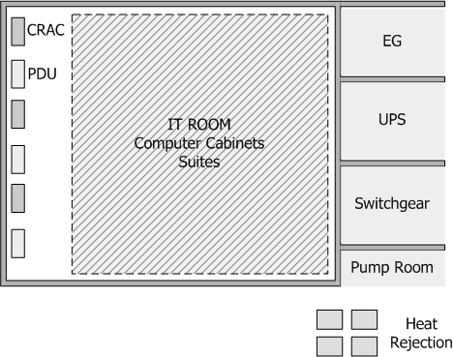
Figure 1.1 Typical Data Center Infrastructure Error! Reference source not found.Error! Reference source not found.
The overall design of a data centre can be classified in 4 categories Tier I-IV each one presenting advantages and disadvantages related to power consumption and availability [3]-[6]. In most cases availability and safety issues yield to redundant N+1, N+2 or 2N data centre designs and this has a serious effect on power consumption. According to [7], a data centre has the following main units.

Table 1.1 Technology Overview
Column 1 Title | Column 2 Title | Column 3 Title | Column n Title

Power Consumption in Data Centres
of their maximum capacity workloads, the efficiency of the UPS cannot be considered constant and equal to the imposed by the manufacturer value.
In general energy efficiency in the telecommunication industry is related to
(1. 1)
The optimal description of this value depends on the system’s characteristics and the type of equipment. As an example, for modulation and coding techniques in wireless communications the spectral efficiency is a common measure. For electronic components, the ratio of joule per bit best describes performance. In telecommunication networks and datacentres, the ratio of watts consumed over the Gbps of data processed is preferred. In [8] an absolute energy efficiency metric is introduced, named as dBε. The metric is computed according to the equation:
(1.2)

Energy efficiency in Data Centres
Data centre energy efficiency text.

Conclusion
A concise summary of the findings and a clear identification of the advance/contribution that this work provides to the field.
Acknowledgements

Figures and Tables Caption List

References

- S. J. Prince, Computer vision: models, learning, and inference. Cam-bridge University Press, 2012.
- D. Lu and Q. Weng, “A survey of image classification methods and tech-niques for improving classification performance,” International journal of Remote sensing, vol. 28, no. 5, pp. 823–870, 2007.
- J. Du, “Understanding of object detection based on cnn family and yolo,” in Journal of Physics: Conference Series, vol. 1004. IOP Publishing, 2018, p. 012029.
- X. Li, Z. Zhou, P. L. Mazzeo, S. Ramakrishnan, and P. Spagnolo, “Object re-identification based on deep learning,” Visual Object Tracking with Deep Neural Networks, 2019.
- J. Barthélemy, N. Verstaevel, H. Forehead, and P. Perez, “Edge-computing video analytics for real-time traffic monitoring in a smart city,” Sensors, vol. 19, no. 9, p. 2048, 2019.
- C. Wang, Y. Yang, M. Qi, and H. Ma, “Efficient cloud-edge collaborative inference for object re-identification,” arXiv preprint arXiv:2401.02041, 2024.
- K. Cao, Y. Liu, G. Meng, and Q. Sun, “An overview on edge computing research,” IEEE access, vol. 8, pp. 85 714–85 728, 2020.
- R. Kuma, E. Weill, F. Aghdasi, and P. Sriram, “Vehicle re-identification: an efficient baseline using triplet embedding,” in 2019 International Joint Conference on Neural Networks (IJCNN). IEEE, 2019, pp. 1–9.
- S. Rath, “Yolov8 : Comprehensive guide to state of the art object detection,” https://learnopencv.com/ultralytics-yolov8/#YOLOv8-vs-YOLOv5, 2023, accessed: September 23, 2024.
- A. O. Salau and S. Jain, “Feature extraction: a survey of the types, techniques, applications,” in 2019 international conference on signal processing and communication (ICSC). IEEE, 2019, pp. 158–164.
- Z. Zheng, X. Yang, Z. Yu, L. Zheng, Y. Yang, and J. Kautz, “Joint discriminative and generative learning for person re-identification,” in proceedings of the IEEE/CVF conference on computer vision and pattern recognition, 2019, pp. 2138–2147.
- E. Almeida, B. Silva, and J. Batista, “Strength in diversity: Multi-branch representation learning for vehicle re-identification,” in 2023 IEEE 26th International Conference on Intelligent Transportation Systems (ITSC). IEEE, 2023, pp. 4690–4696.
- S. V. Huynh, “A strong baseline for vehicle re-identification,” in Pro-ceedings of the IEEE/CVF conference on computer vision and pattern recognition, 2021, pp. 4147–4154.
- Z. Zheng, T. Ruan, Y. Wei, and Y. Yang, “Vehiclenet: Learning robust feature representation for vehicle re-identification.” in CVPR Workshops, vol. 2, no. 3, 2019.
- Z. Zheng, L. Zheng, and Y. Yang, “A discriminatively learned cnn embedding for person reidentification,” ACM transactions on multimedia computing, communications, and applications (TOMM), vol. 14, no. 1, pp. 1–20, 2017.
- Z. Zheng, T. Ruan, Y. Wei, Y. Yang, and T. Mei, “Vehiclenet: Learning robust visual representation for vehicle re-identification,” IEEE Trans-actions on Multimedia, vol. 23, pp. 2683–2693, 2020.
- Papers with Code, “Vehicle re-identification benchmarks,” https://paperswithcode.com/task/vehicle-re-identification#benchmarks, accessed: September 23, 2024.
- ——, “Person re-identification benchmarks,” https://paperswithcode.com/task/person-re-identification, accessed: September 24, 2024.
- C. Sharma, S. R. Kapil, and D. Chapman, “Person re-identification with a locally aware transformer,” arXiv preprint arXiv:2106.03720, 2021.
- M. Wieczorek, B. Rychalska, and J. Dabrowski, “On the unreasonable effectiveness of centroids in image retrieval,” in Neural Information Processing: 28th International Conference, ICONIP 2021, Sanur, Bali, Indonesia, December 8–12, 2021, Proceedings, Part IV 28. Springer, 2021, pp. 212–223.
- L. Wen, D. Du, Z. Cai, Z. Lei, M.-C. Chang, H. Qi, J. Lim, M.-H. Yang, and S. Lyu, “Ua-detrac: A new benchmark and protocol for multi-object detection and tracking,” Computer Vision and Image Understanding, vol. 193, p. 102907, 2020.
- H. Liu, Y. Tian, Y. Yang, L. Pang, and T. Huang, “Deep relative distance learning: Tell the difference between similar vehicles,” in Proceedings of the IEEE conference on computer vision and pattern recognition, 2016, pp. 2167–2175.
- X. Liu, W. Liu, T. Mei, and H. Ma, “A deep learning-based approach to progressive vehicle re-identification for urban surveillance,” in Computer Vision–ECCV 2016: 14th European Conference, Amsterdam, The Netherlands, October 11-14, 2016, Proceedings, Part II 14. Springer, 2016, pp. 869–884.
- Z. Tang, M. Naphade, M.-Y. Liu, X. Yang, S. Birchfield, S. Wang, R. Kumar, D. Anastasiu, and J.-N. Hwang, “Cityflow: A city-scale benchmark for multi-target multi-camera vehicle tracking and re-identification,” in Proceedings of the IEEE/CVF Conference on Computer Vision and Pattern Recognition, 2019, pp. 8797–8806.
- AI City Challenge, “2020 data and evaluation,” https://www.aicitychallenge.org/2020-data-and-evaluation/, 2020, accessed: September 24, 2024.
- Y. Yao, L. Zheng, X. Yang, M. Naphade, and T. Gedeon, “Simulating content consistent vehicle datasets with attribute descent,” in Computer Vision–ECCV 2020: 16th European Conference, Glasgow, UK, August 23–28, 2020, Proceedings, Part VI 16. Springer, 2020, pp. 775–791.
- layumi, “Pytorch reid github repository,” https://github.com/layumi/Person reID baseline pytorch/, accessed: September 24, 2024.
- R. J. Bayardo, Y. Ma, and R. Srikant, “Scaling up all pairs similarity search,” in Proceedings of the 16th international conference on World Wide Web, 2007, pp. 131–140.
- T. Taipalus, “Vector database management systems: Fundamental concepts, use-cases, and current challenges,” Cognitive Systems Research, vol. 85, p. 101216, 2024.
- S. Valladares, M. Toscano, R. Tufiño, P. Morillo, and D. Vallejo-Huanga, “Performance evaluation of the nvidia jetson nano through a real-time machine learning application,” in Intelligent Human Systems Integration 2021: Proceedings of the 4th International Conference on Intelligent Human Systems Integration (IHSI 2021): Integrating People and Intelligent Systems, February 22-24, 2021, Palermo, Italy. Springer, 2021, pp. 343–349.
- AXIS communications, “Product support for axis p1427-le network camera,” https://www.axis.com/products/axis-p1427-le/support, accessed: September 26, 2024.
- Y. Zhang et al., “ByteTrack: Multi-Object Tracking by Associating Every Detection Box,” arXiv (Cornell University), Oct. 2021, doi: https://doi.org/10.48550/arxiv.2110.06864.
- lancedb, “GitHub - lancedb/lancedb: Developer-friendly, serverless vector database for AI applications. Easily add long-term memory to your LLM apps!,” GitHub, Sep. 24, 2024. https://github.com/lancedb/lancedb (accessed Oct. 03, 2024).

References in Text
References cited in the text need to appear on the line, in square brackets, inside the punctuation. Grammatically, they may be treated as if they were footnote numbers, e.g.: as shown by Brown [4], [5]; as mentioned earlier [2], [4]–[7], [9]; Smith [4] and Brown and Jones [5]; Wood et al. [7]
NOTE: Use et al. when three or more names are given for a reference cited in the text.
or as nouns:
as demonstrated in [3]; according to [4] and [6]–[9].
STYLE
Reference numbers are set flush left and form a column of their own, hanging out beyond the body of the reference.
The reference numbers are on the line, enclosed in square brackets. In all references, the given name of the author or editor is abbreviated to the initial only and precedes the last name. The IEEE referencing is required.
You can find here the link to a free IEEE citation generator: https://www.mybib.com/tools/ieee-citation-generator that generates accurate IEEE style citations quickly and automatically.
Publications must list names of all authors, up to six names. If there are more than six names listed, use the primary author’s name followed by et al. For non-IEEE publications, et al. may be used if names are not provided. All references, except those ending with URLs, will end with a period, including those with a DOI. However, if a reference contains both a DOI or accessed date, as well as a URL, place the DOI after the URL and end with a period. Note that when citing IEEE Transactions, if the issue number or month is not available, research IEEEXplore to update the information. For any reference that cites two months for the same issue, the two months should be separated by a slash (e.g., Jul./Aug.), followed by the year of publication. References may not include all information; please obtain and include relevant information. Do not combine references. There must be only one reference with each number. If there is a URL included with the print reference, it can be included at the end of the reference (see style for online references).

